**Gaussian distribution**

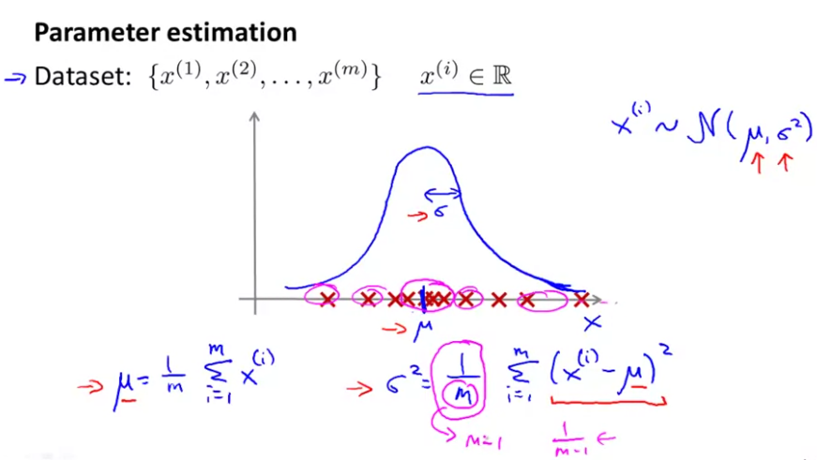

**Anomaly detection algorithm**

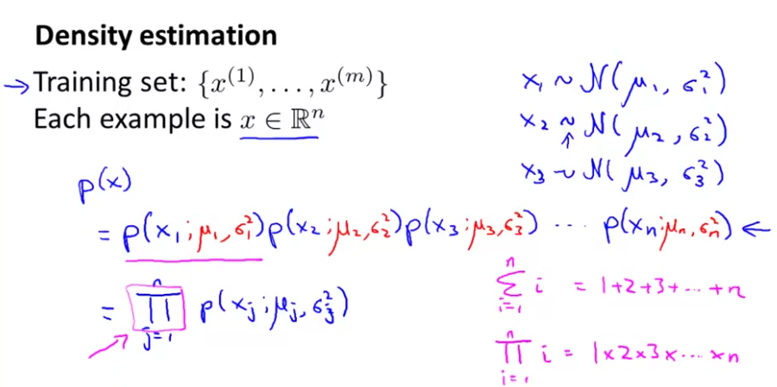

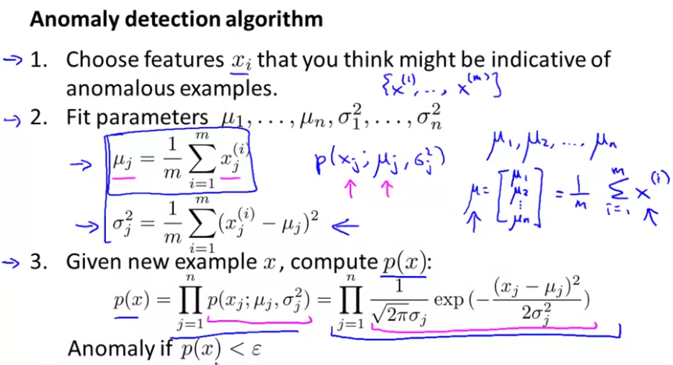

**Developing and Evaluating an Anomaly Detection System**

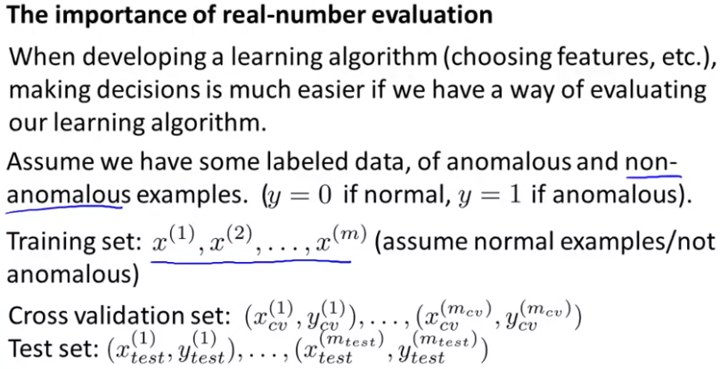

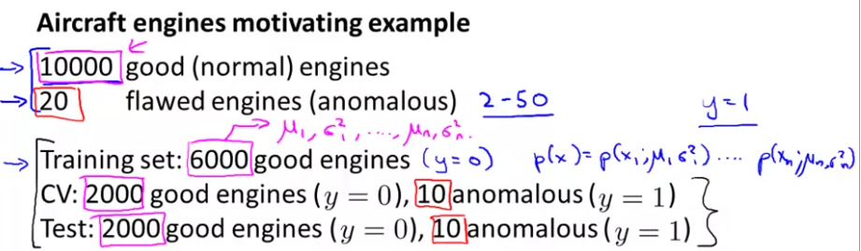

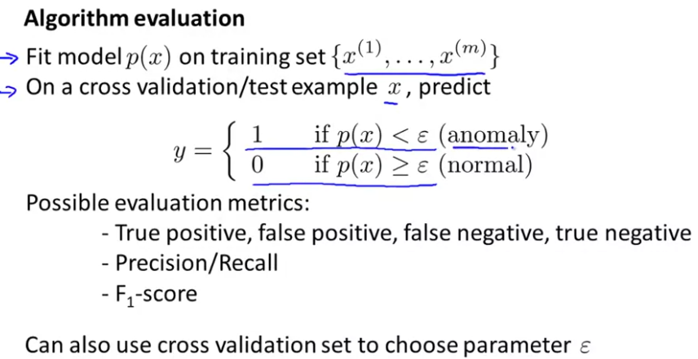

You can pick the value of epsilon that maximizes f1 score, or that otherwise does well on your cross validation set.

**Anomaly Detection vs Supervised Learning**

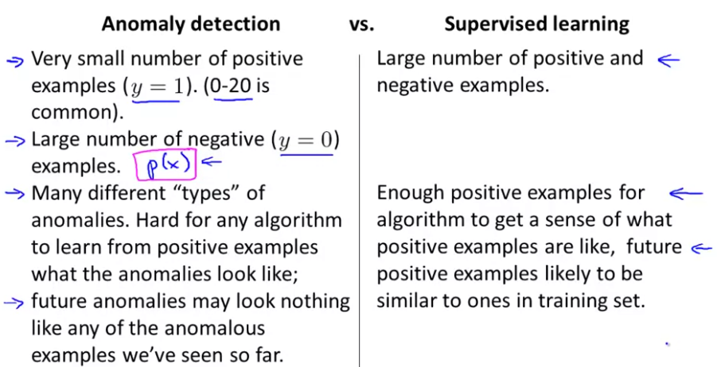

**Choosing what features to use**

We need to use features that correspond to a Gaussian distribution. If they don’t naturally follow this distribution, you can apply transformations to make them look more Gaussian:

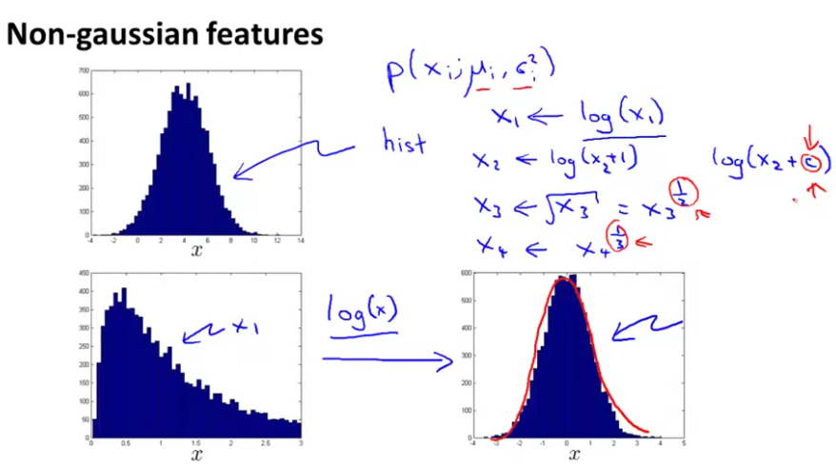

**Multivariate Gaussian distribution**

It’s useful for when you cannot make the difference between normal and anomalous examples by looking at the features separately.

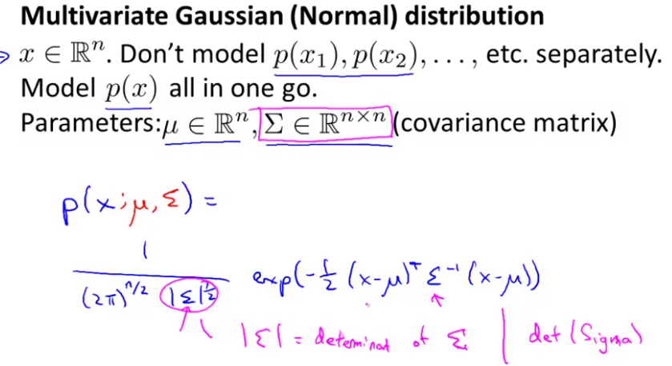

**Anomaly Detection using the Multivariate Gaussian Distribution**

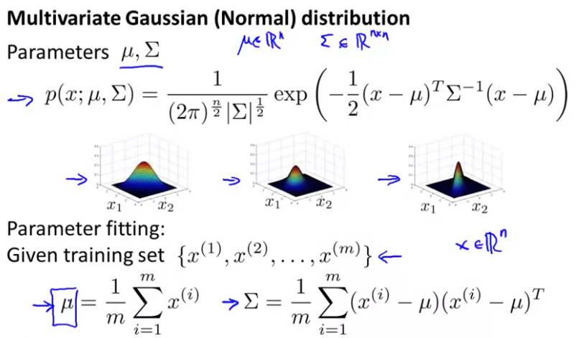

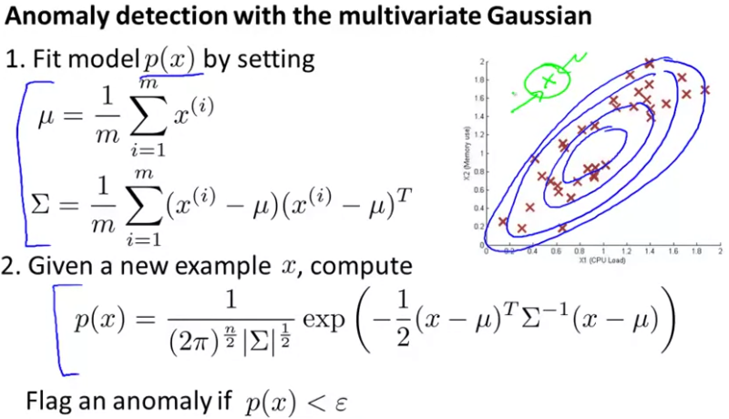

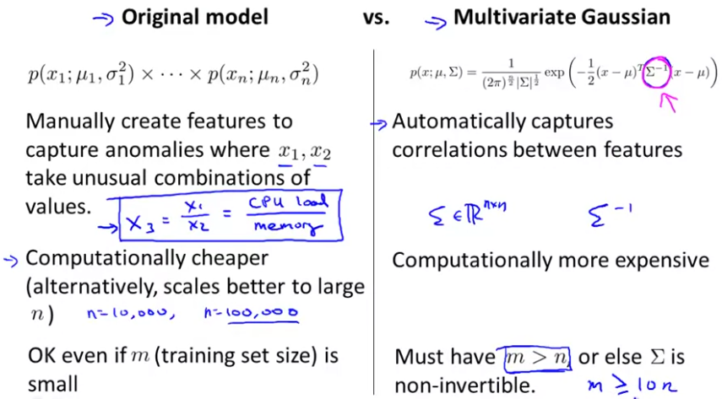

In problems where you have a very large training set or m is very large and n is not too large, then the multivariate Gaussian model is well worth considering and may work better as well, and can save you from having to spend your time to manually create extra features in case the anomalies turn out to be captured by unusual combinations of values of the features.

If you find that the covariance matrix sigma is singular, or you find it's non-invertible, they're usually 2 cases for this. One is if it's failing to satisfy this m greater than n condition, and the second case is if you have redundant features (if you have 2 features that are the same).